YARD DUTY AND SUPERVISION POLICY
Purpose
To ensure school staff understand their supervision and yard duty responsibilities.

Scope

This policy applies to all teaching and non-teaching staff at Lightning Reef Primary School, including education support staff, casual relief teachers and visiting teachers.

Policy
Appropriate supervision is an important strategy to monitor student behaviour and enables staff to identify and respond to possible risks at school as they arise. It also plays a vital role in helping schools to discharge their duty of care to students.
The Principal is responsible for ensuring that there is a well organised and responsive system of supervision and yard duty in place during school hours, before and after school, and on school excursions and camps and other school activities.
School staff are responsible for following reasonable and lawful instructions from the Principal, including instructions to provide supervision to students at specific dates, times and places.

Before and after school
Lightning Reef Primary School’s grounds are supervised by school staff from 8:30am until 3:30pm. Outside of these hours, school staff will not be available to supervise students.
Before school, school staff will be available to supervise the back gate, courtyard and basketball courts only. Students are to stay in these designated areas.
After school, each gate is supervised along with one teacher designated to walk students across the road to the Bus Stop at 3.35 daily. Students are to wait for adults picking them up outside with teachers on duty until 3.30 pm, at which time teachers will escort remaining students to the front office, where they will remain until collected.
Parents and carers will be advised through regular reminders in our newsletter that they should not allow their children to attend Lightning reef Primary School outside of these hours. Families are encouraged to contact Lightning Reef ELC on 54458330 or refer to http://ifp.mychild.gov.au/ChildCareService/Provider.aspx/12957/Lightning-Reef-Early-Learning-Centre-OSHC for more information about the before and after school care facilities available to our school community.
If a student arrives at school before supervision commences at the beginning of the day, the Principal or nominee staff member will, as soon as practicable, follow up with the parent/carer to:
- advise of the supervision arrangements before school
- request that the parent/carer make alternate arrangements.
If a student is not collected before supervision finishes at the end of the day, the Principal or nominee staff member will consider whether it is appropriate to:
- attempt to contact the parents/carers
- attempt to contact the emergency contacts
- place the student in an out of school hours care program (if available and the parent consents)
- contact Victoria Police and/or Child Protection to arrange for the supervision, care and protection of the student.
Yard duty zones
All staff at Lightning Reef Primary School are expected to assist with yard duty supervision and will be included in the weekly roster.
The Principal is responsible for preparing and communicating the yard duty roster on a regular basis. At Lightning Reef Primary School, school staff will be designated a specific yard duty area to supervise.
The designated yard duty areas for our school (as at Term 4, 2021) are as follows;
Zone | Area
Oval | Roving oval, including soccer pitch, behind containers and the senior GaGa Pit.
Basketball Court | Roving Basketball Court, Spider net and Playground.
Courtyard | Roving courtyard, toilets, sandpit, Junior Ga Ga Pit and small oval
Refresh | Inside activities including Refresh Room, which provides a space for students to reflect on an incident earlier in the day, discuss with an adult and refresh for activities.
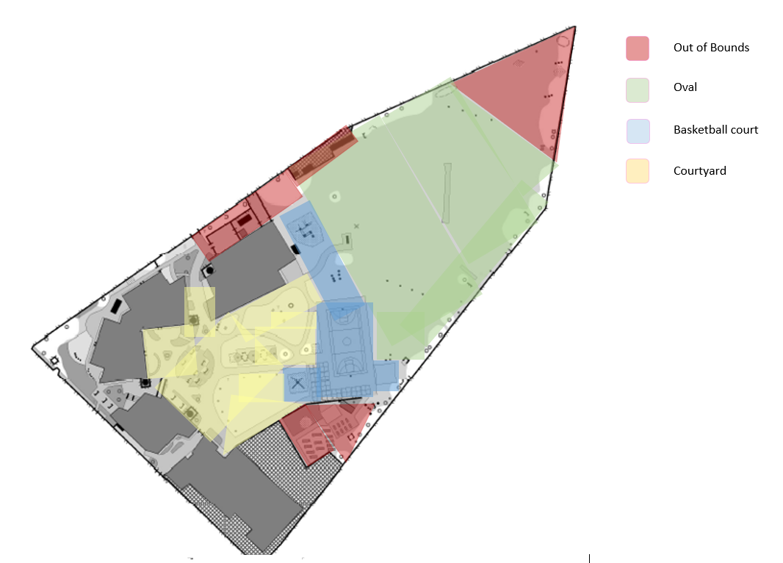
INSERT SCHOOL MAP WITH ZONES MARKED
Yard duty equipment
School staff must:
- wear a provided safety/hi-vis vest whilst on yard duty. Safety/hi-vis vests will be provided. Additionally, spare vests are available from the main office.
- Be familiar with the yard duty information pack containing student health and safety information.
Yard duty responsibilities
Staff who are rostered for yard duty must remain in the designated area until they are replaced by a relieving staff member.
During yard duty, supervising school staff must:
- methodically move around the designated zone to ensure that all areas are within line of sight to at least one yard duty teacher at a time.
- be alert and vigilant
- intervene immediately if potentially dangerous or inappropriate behaviour is observed in the yard
- enforce behavioural standards and implement appropriate consequences for breaches of safety rules, in accordance with any relevant disciplinary measures set out in the school’s Student Engagement and Wellbeing policy
- ensure that students who require first aid assistance receive it as soon as practicable
- log any incidents or near misses as appropriate on Sentral or report to the Leading Teacher – Student Wellbeing
If being relieved of their yard duty shift by another staff member (for example, where the shift is ‘split’ into 2 consecutive time periods), the staff member must ensure that a brief but adequate verbal ‘handover’ is given to the relieving staff member in relation to any issues which may have arisen during the first shift.
If the supervising staff member is unable to conduct yard duty at the designated time, they should contact a member of the Leadership Team with as much notice as possible prior to the relevant yard duty shift to ensure that alternative arrangements are made.
If the supervising staff member needs to leave yard duty during the allocated time, they should contact a member of the Leadership Team but should not leave the designated area until the relieving staff member has arrived in the designated area.
If the relieving staff member does not arrive for yard duty, the staff member currently on duty should send a responsible student into the office to ask for assistance and not leave the designated area until a replacement staff member has arrived.
Students will be encouraged to speak to the supervising yard duty staff member if they require assistance during recess or lunchtime.

Classroom
The classroom teacher is responsible for the supervision of all students in their care during class.
If a teacher needs to leave the classroom unattended at any time during a lesson, they should first contact a member of the Leadership Team. The teacher should then wait until a replacement staff member has arrived at the classroom before leaving.

School activities, camps and excursions
The Principal and leadership team are responsible for ensuring that students are appropriately supervised during all school activities, camps and excursions, including when external providers are engaged to conduct part or all of the activity. Appropriate supervision will be planned for school activities, camps and excursions on an individual basis, depending on the activities to be undertaken and the level of potential risk involved.

Digital devices and virtual classroom
Lightning Reef Primary School follows the Department’s Cybersafety and Responsible Use of Technologies Policy with respect to supervision of students using digital devices.

Students requiring additional supervision support
Sometimes students will require additional supervision, such as students with disability or other additional needs. In these cases, the Principal or delegate will ensure arrangements are made to roster additional staff as required. This may include on yard duty, in the classroom or during school activities.

Supervision of student in emergency operating environments
In emergency circumstances our school will follow our Emergency Management Plan, including with respect to supervision.
In the event of any mandatory period of remote or flexible learning our School will follow the operations guidance issued by the Department.
COMMUNICATION

This policy will be communicated to our school community in the following ways:

- Included in staff induction processes
- Discussed at staff briefings or meetings and staff bulletins, as required
- Included as a reference in our school newsletter each semester
- Made available in hard copy from school administration upon request

Information for parents and students on supervision before and after school is available on our school website and parent reminders are sent at the beginning of each term in our school newsletter.

Further Information and Resources
- the Department’s Policy and Advisory Library (PAL):
  - Child Safe Standards
  - Cybersafety and Responsible Use of Technologies
  - Duty of Care
  - Excursions
  - Supervision of Students
  - Visitors in Schools

POLICY REVIEW AND APPROVAL

Policy last reviewed | 12/11/2021
Approved by | Principal
Next scheduled review date | 12/11/2022

This policy will also be updated if significant changes are made to school grounds that require a revision of Lightning Reef Primary School’s yard duty and supervision arrangements.

