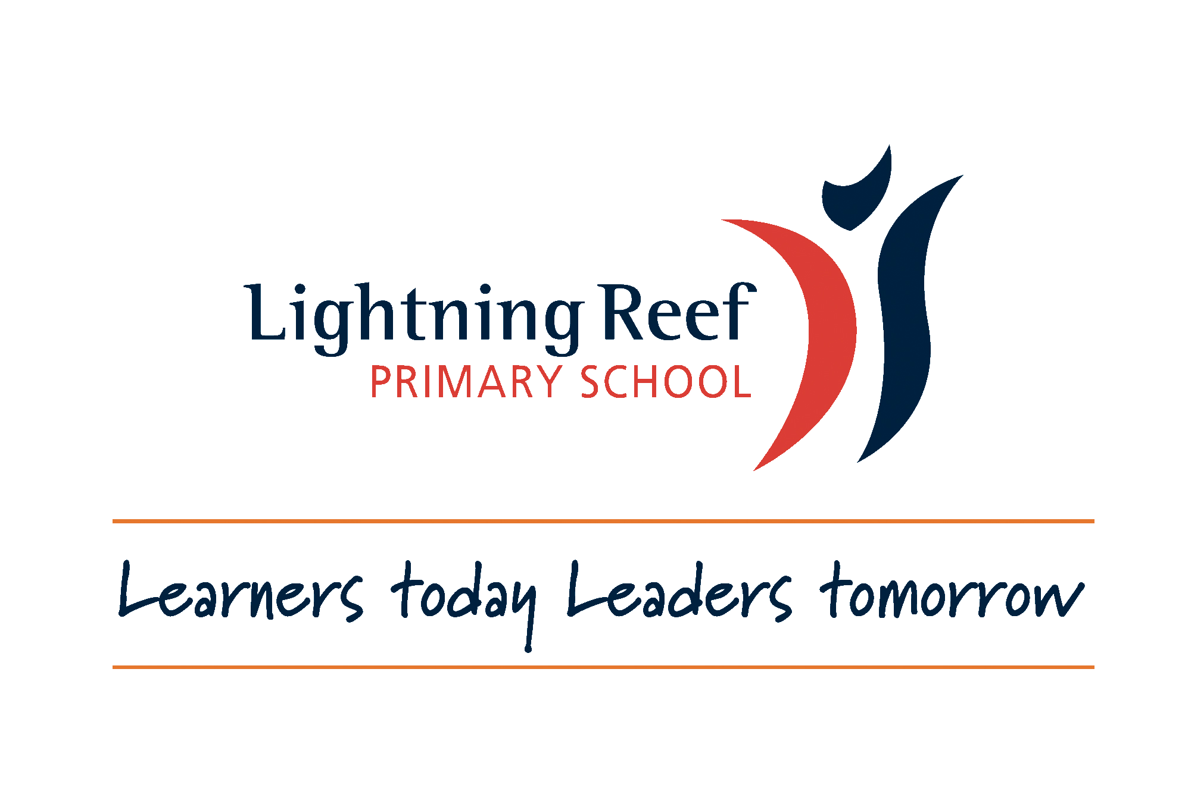

**School Wide Positive Behaviour Support**

**Staff Handbook**

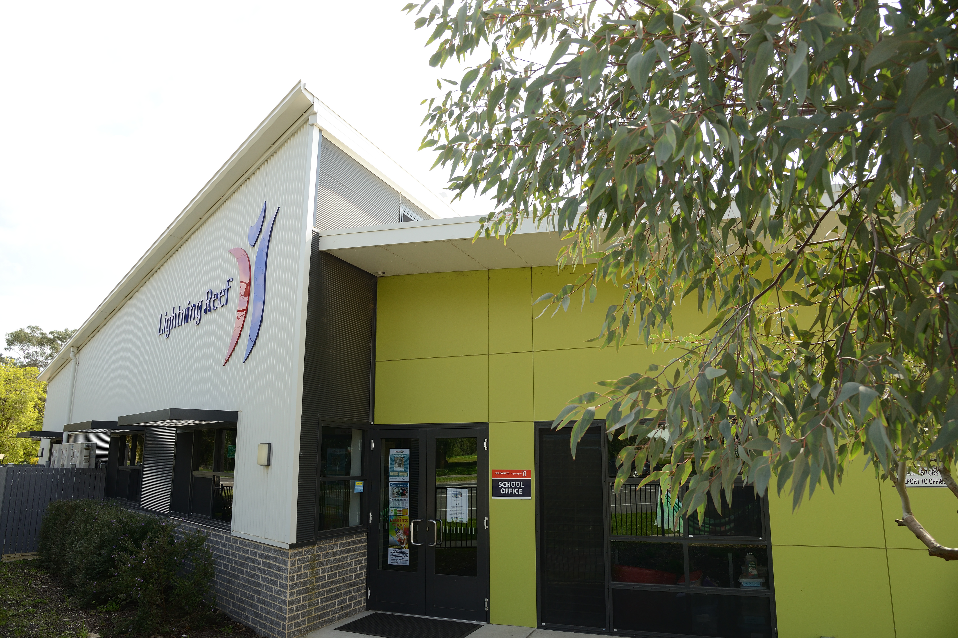

RESPECT RESPONSIBILITY CO-OPERATION BE YOUR BEST

**What is SWPBS**

SWPBS is an evidence-based framework for preventing and responding to behaviours in schools. It includes a system of tools and strategies for defining and teaching positive behaviours, acknowledging appropriate behaviour and correcting inappropriate behaviour through explicit teaching and modelling. It aims to create a positive school climate, a culture of student competence and an open, responsive management system for school leaders, staff, students, parents/carers. The goal is to create an environment that promotes success for all students.

SWPBS runs along a continuum from Tier 1 for all students, Tier 2 for a small cohort of students to Tier 3 for individual students. Students will move up and down these tiers throughout their time at school.

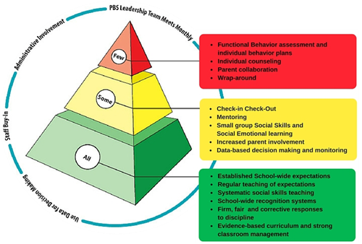

An important aspect of SWPBS is the understanding that appropriate behaviour and social competence is a skill that requires direct teaching to students just like maths and reading. There is no assumption, in SWPBS, that students will learn social behaviour automatically or pick it up as they go through life. This critical feature of SWPBS leads to its effectiveness.

**We cannot ‘fix’ a student. We can redesign the environment and implement teaching strategies and interventions to promote student success.**

**Purpose Statement**

**At our school we act respectfully, take responsibility, cooperate and strive to be our best.**

**Values**

**Be your best**

We strive to be our very best in everything we do.

Co-operation

We co-operate with our friends, peers, teachers, parents and the community.

Respect

We respect ourselves, others and our environment.

Responsibility

We take care of others, our belongings, the environment and ourselves.

**Mantras**

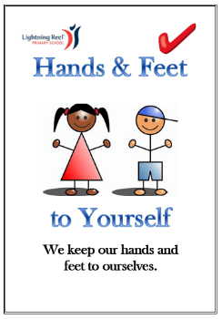 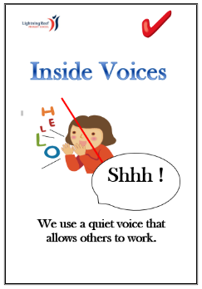 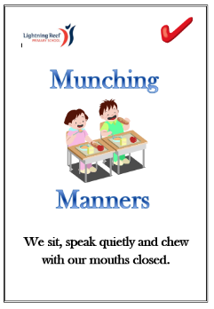 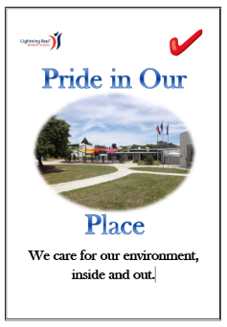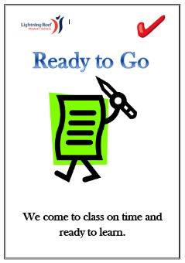

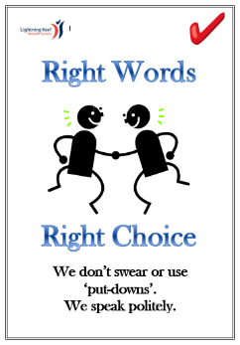 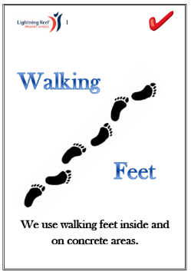

**Behaviour Expectations**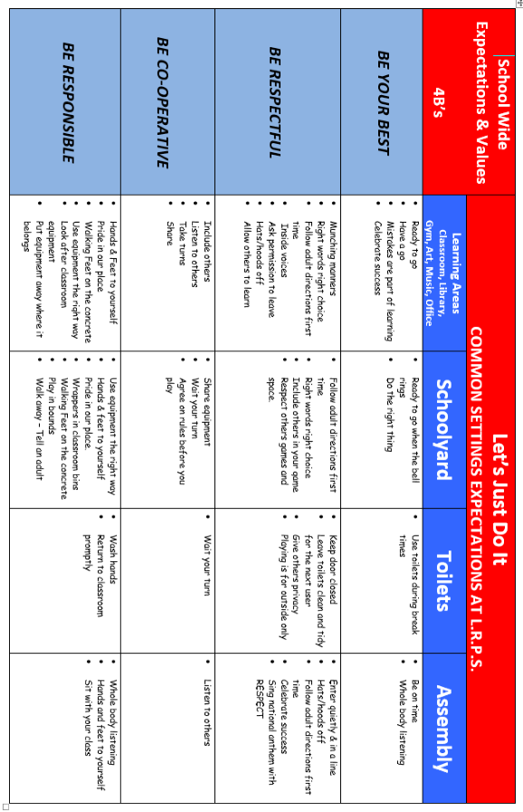

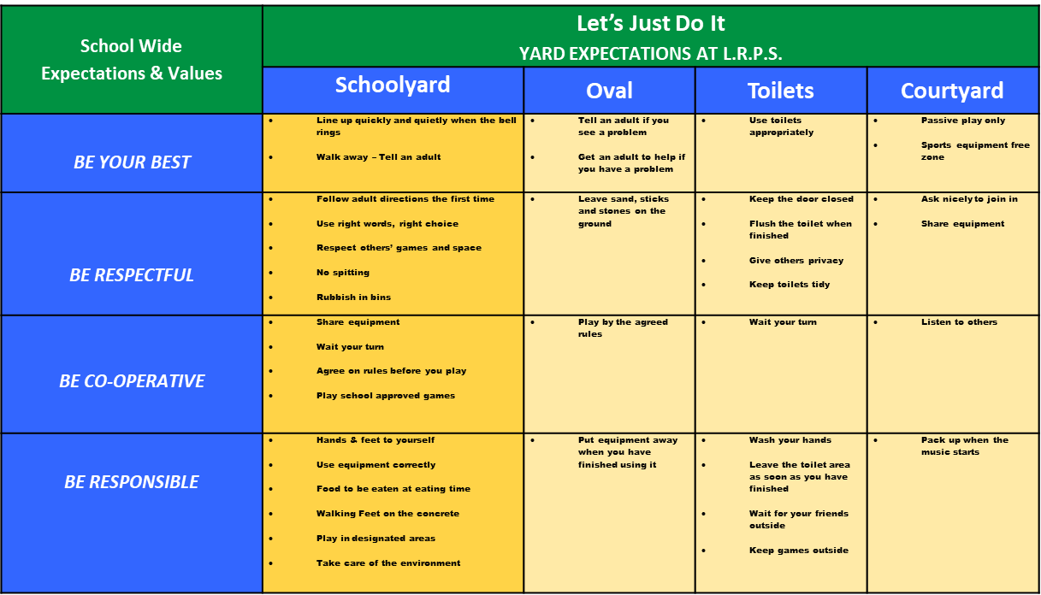

**How to use the Behaviour Expectations Matrix**

The Behaviour Expectation Matrix translates our values (Be Your Best, Be Respectful, Be Co-operative and Be Responsible) into expected behaviours. Expected behaviours are explicitly taught in the classrooms during P.I.E sessions and reminders made throughout the day. The matrix is displayed in each classroom around the school. It is referred to and discussed regularly with our students.

The matrix is also designed for staff to use to identify students displaying our expected behaviours and reward students for doing so either through behaviour specific verbal praise or with a BRAG TAG.

**BRAG TAGS**

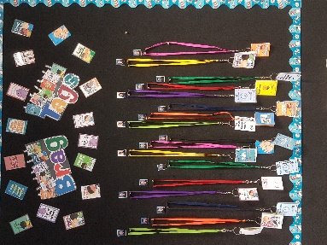 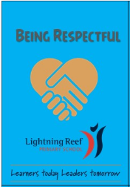 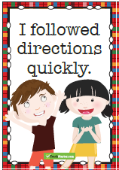 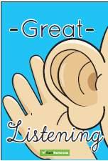

Brag Tags are used by staff to reward students who have consistently displayed expected behaviours (see matrix above). They can also be used to reward students who are learning a new behaviour/skill and may be given out more regularly as they begin displaying this behaviour/skill. (These would decrease as the behaviour/skill becomes a regular practice for the student).

When giving out Brag Tags it is important that you use explicit, behaviour specific language.

**For example**:

“Tommy, well done for being respectful and listening when instruction were being given”

“Mary, well done for being responsible by putting equipment away where it belongs”

“John, well done for being your best by showing whole body listening during assembly”

**Rewards**

Rewards are an effective, important and functional part of any educational context, and need not be detrimental to intrinsic motivation. Rewards are especially important for helping motivate a child to build early competence (fluency) with reading, math or social skills. Encouragement, guidance and reward of appropriate approximations of successful behaviour are helpful for students to build the skills that can then be sustained by the natural consequences from reading well, joining games with peers, or playing a musical instrument. Rewards also are important for building a predictable, positive social culture in a school. Schools with clearly defined behavioural expectations, and formal strategies for acknowledging (rewarding) appropriate behaviour, are perceived as safer, more effective learning environments. The delivery of rewards is one overt way that children learn that adults are serious about the social and academic goals they are teaching. Students are motivated by positive rewards, especially when they have had a hand in selecting and defining the rewards themselves. Students remain engaged when they have a positive incentive and are self-motivated to earn rewards. SWPBS incentive rewards offer tangible signs of progress and success, provides students with positive feedback and helps reinforce positive behaviours and expectations.

**Managing Student Behaviour**

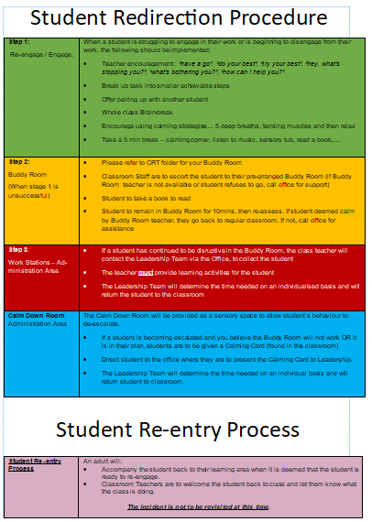

Ideally we would like all students to remain in their classrooms, however there are times when a student will need support with this or given time to calm and settle before returning to their own class to continue with their learning. There will be times when a behaviour is extreme. At these times leadership may be called as your first step to prevent major class disruptions or harm to student or others.

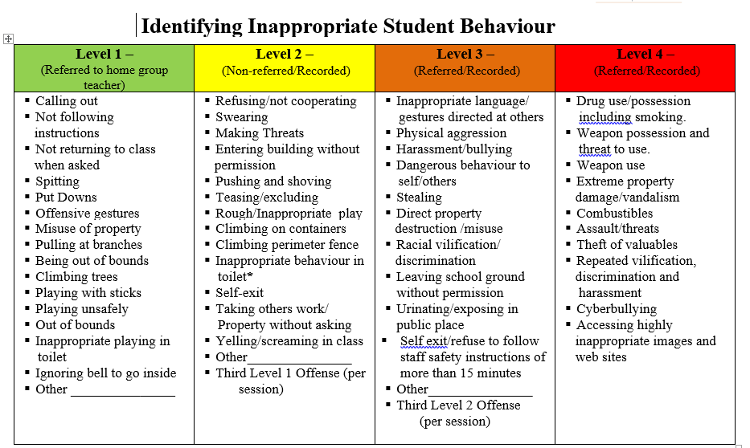

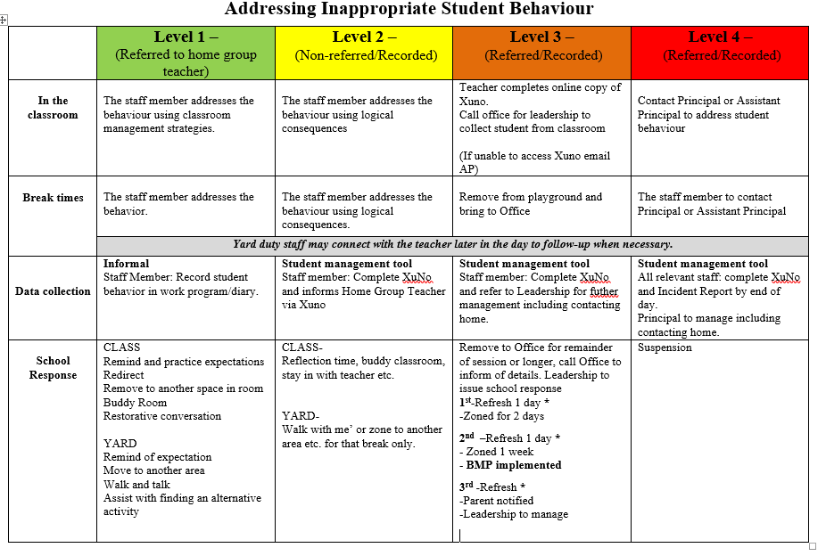

To support our clear, fair and consistent rules and behavioural expectations the above matrix was developed to provide reasonable and consistent consequences across the school. It is important that staff discuss the ‘Identifying Inappropriate Behaviour’ matrix to ensure that all students understand the behaviours included e.g. physical aggression = hands and/or feet on, racial vilification = saying nasty things about someone because of the colour of their skin/where they were born. Teachers are to manage level 1 and 2 behaviours in the classroom (refer to ‘Student Redirection Procedure’ for further supports) All level 2, 3 and 4 behaviours must be entered onto our student management system (Sentral) by the person who dealt with the incident, as soon as possible after it. All staff, including CRTs, should have access to Sentral, if you do not have access please ask for help or email a brief description of the incident to leadership.

**Refresh**

Any student who displays a level 3 behaviour will need to attend refresh. Refresh is run in the Library at second break every day.

Before a student can attend Refresh the following **must** occur:

1. Incident entered onto student management system
2. Student spoken with an adult to unpack the incident
3. Student’s name is on the daily Refresh email sent out to all staff.

If Refresh is to be effective it is vital that the above steps are followed. There will be times that certain students cannot attend Refresh together and alternative arrangements will need to be made, or additional staff bought in if there is a large group*. One student who has not had the opportunity to unpack the incident can undo the session and make it a very volatile and unproductive environment.*

If a student is involved in an incident and the above steps have not or are not able to occur before Refresh begins, they will need to attend Refresh the following day. If an incident occurs during break time, students are to be sent to the office for the remainder of the break.

**Behaviour Support Plans**

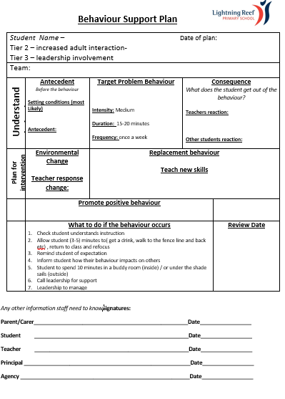

Behaviour Support Plans are a positive process for improving behaviour. When a student reaches the 2nd Level 3 incident, a Behaviour Support Plan will be negotiated. This will involve the class teacher, the Wellbeing and Inclusion teacher and the student. The BMP will then be shared with the parent including suggestions for home support. The BMP may also include school based counseling or outside agency support.

Behaviour Support Plans will include:

* A description of the antecedent, behaviour and consequence
* SMART Goal – describing desirable behaviour
* Environmental changes to be made
* Teacher Response
* Strategies to teach the new behaviour
* On-going monitoring
* Steps for when undesirable behaviour occurs

All staff will be informed so that consistent expectations and school responses are maintained.

**Check In Process**

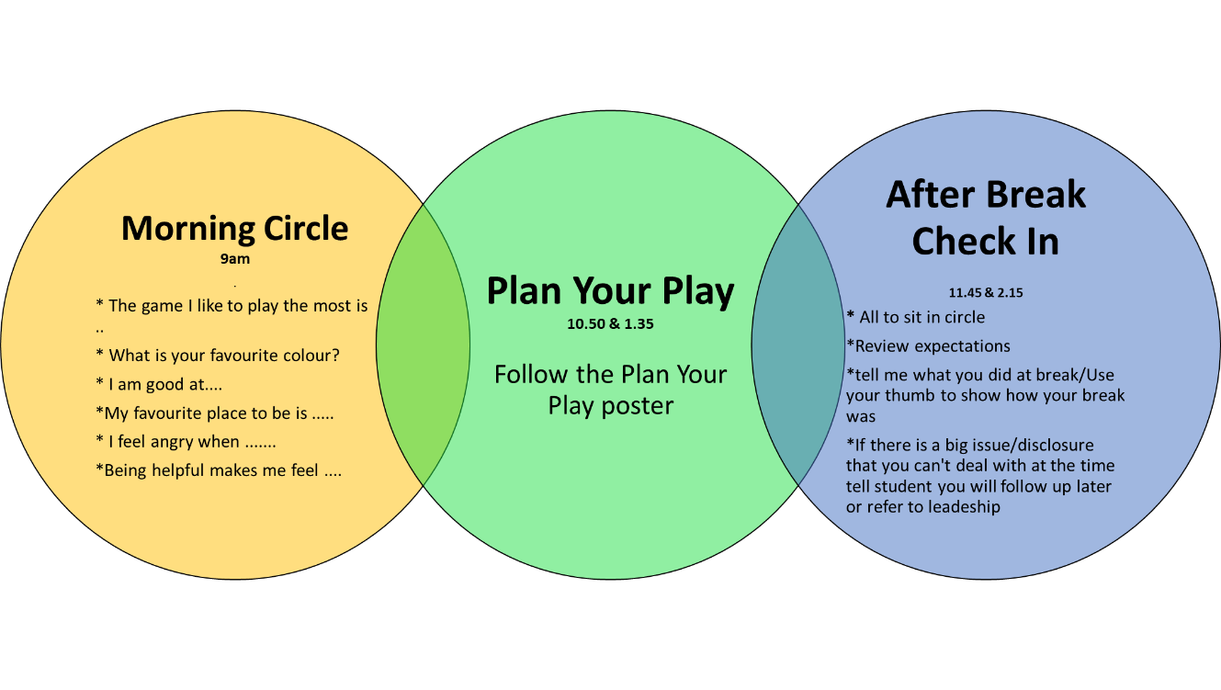

**Morning Circle - Purpose**

* *To provide a safe space where everyone has an equal opportunity to speak and be heard.*
* *To share a conversation to gauge the emotional state of students at the start of the day and to provide additional supports or opportunities to speak to an adult, to help them be ready to learn*

All students are to sit in a circle. Ask a question to each student (see visual above for examples). You are looking for differences in body language, tone, anything different from the norm. If you are concerned catch up with the student as soon as possible and provide them with the supports they need to help them be ready to learn. If the problem/concern is too big to be handled within the classroom refer them onto Social Worker/Leadership.

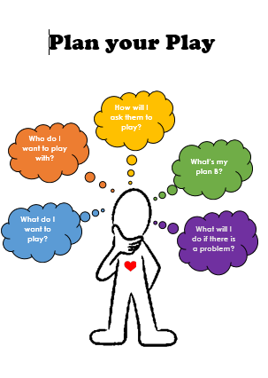

Plan Your Play is about supporting students to plan who they are going to play with and what they are going to do during break time. It also encourages students to come up with a plan B if something goes wrong.

Teachers are to provide time before break to go through the questions on the visual, focusing on those students known to struggle during breaks.

**After Break Check-in**

Check in after break is a time is to touch base with everyone and work through any issues that may have occurred in the yard. Students are to sit in a circle on the floor and speak about their break. If a student talks about an incident, this is the time to work through it and move on. If student/s are not ready to have a respectful conversation provide opportunities for the student/s to calm within the classroom. Teacher to follow up with individuals when calm. If the incident involves students from different classrooms, inform the student that this is too big for you to resolve and that you will refer it onto Leadership or Social Worker.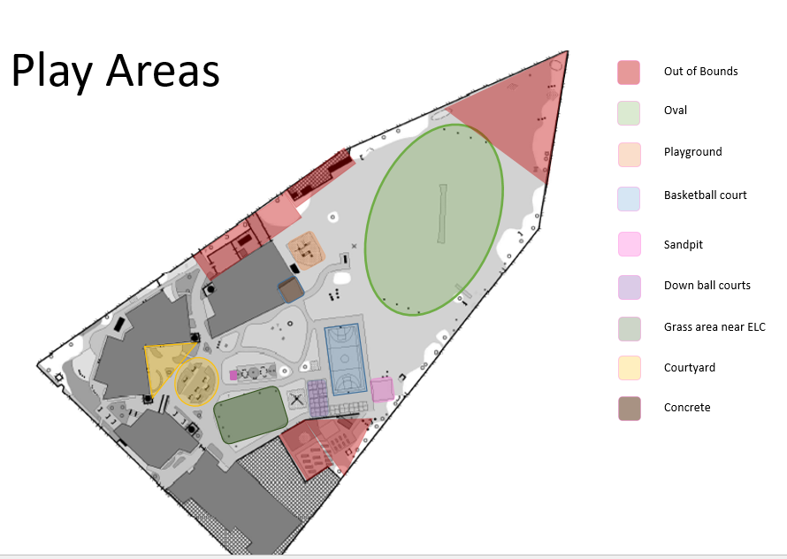

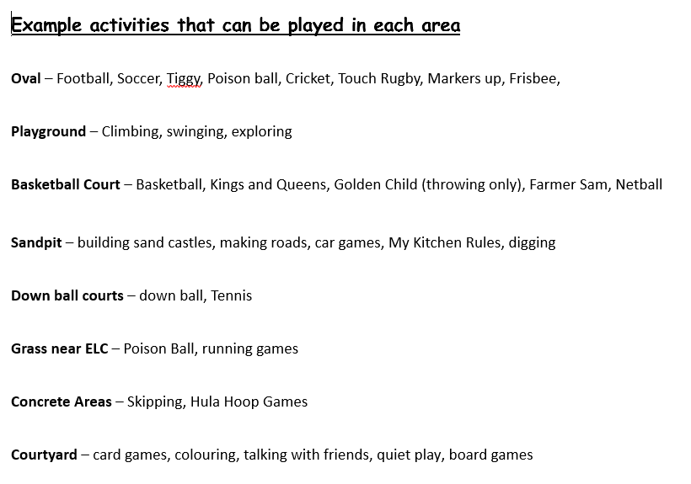

This visual shows the different areas students can play within the yard and provides examples of activities and games that students can play in each area. It is important that you direct students to the correct area depending on the game they are playing.

**Lining up**



